**Superstore Sales and Profit Forecasting Report**

Overview :

In this project we have forecasted category-wise monthly sales and monthly overall profit of the superstore for the years 2018 and 2019 using the SARIMA (Seasonal AutoRegressive Integrated Moving Average) model. SARIMA was chosen since the time series data exhibits both seasonal and non-seasonal components. Historical data from 2014 to 2017 was used to develop and validate the model. The results are visualised through a Power BI dashboard, providing insights into future category-wise performance and aiding in strategic planning for the superstore.

Data Overview :

Historical Data -

- Period Covered: January 2014 - December 2017

- Variables: Sales and Profit

- Data Frequency:Monthly

Forecasting Period -

- Forecasting Years: 2018 and 2019

ARIMA/SARIMA Model :

The SARIMA model was chosen due to its effectiveness in capturing temporal dependencies in time series data and is an essential tool in time series analysis and forecasting, especially when dealing with data that exhibit both trend and seasonal patterns. The model implementation process involved:

1. Stationarity Check: Ensured that the time series monthly sales data for all three categories and monthly overall profit is stationary or not, and if not then differencing was done to transform it to achieve stationarity.

2. Parameter Selection: Used ACF (AutoCorrelation Function) and PACF (Partial AutoCorrelation Function) plots to determine appropriate q (Order of Moving Average) and p (Order of Autoregressive) parameters respectively, d (no. of differences) was determined by number of times the data needs to be differenced in order to achieve stationarity.

In order to obtain seasonal parameters i.e. P,D and Q seasonal first difference data was used in order to remove seasonality and then we plotted PACF and ACF for it to obtain P,D and Q. Since we were operating the model on monthly sales and profit data, so seasonality parameter (s) was chosen as 12.

3. Model Fitting: After obtaining appropriate values of (p,d,q) and (P,D,Q,s) we fitted these values in the SARIMA model and obtained our forecasted results.

Forecast Results :

The SARIMA model generated forecasts for sales and profit for 2018 and 2019. The forecasted values are as follows:

Historical Data Visualization :

- Sales and Profit Trends: Line charts displaying historical trends for sales and profit from 2014 to 2017.

-Seasonality Analysis: Visual analysis was involved in order to determine seasonality trends.

Power BI Dashboard :

The Power BI dashboard was created to visualise the historical and forecasted data effectively. Key features of the dashboard include:

Insights and Recommendations -

Insights

- Growth Trends:The forecast indicates a steady growth in sales for all categories and overall profit over 2018 and 2019, with seasonal peaks and troughs.

- Seasonal Patterns: The analysis shows strong seasonal patterns, which should be considered in inventory and marketing strategies.

Recommendations

1. Inventory Management : Align inventory levels with category-wise forecasted sales peaks to avoid stockouts and overstock situations.

2. Marketing Strategies : Increase marketing efforts during forecasted peak periods to maximise sales opportunities.

3. Financial Planning : Use forecasted profit data for budgeting and financial planning to ensure resources are allocated efficiently.

Dashboard Visuals :

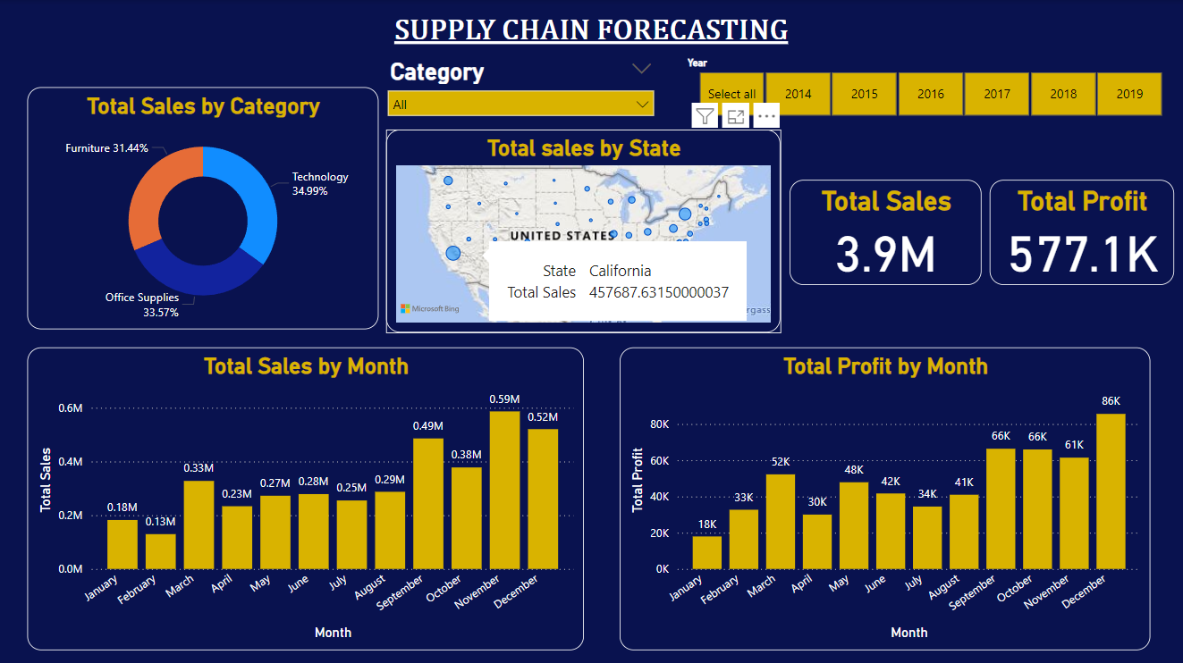

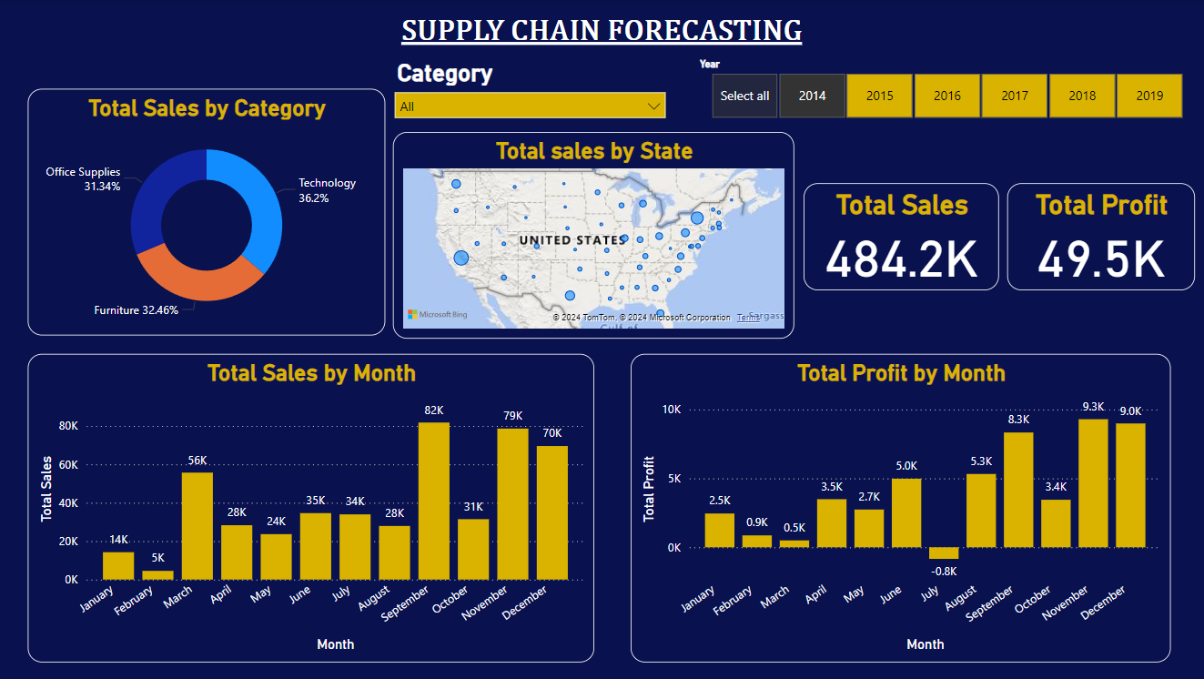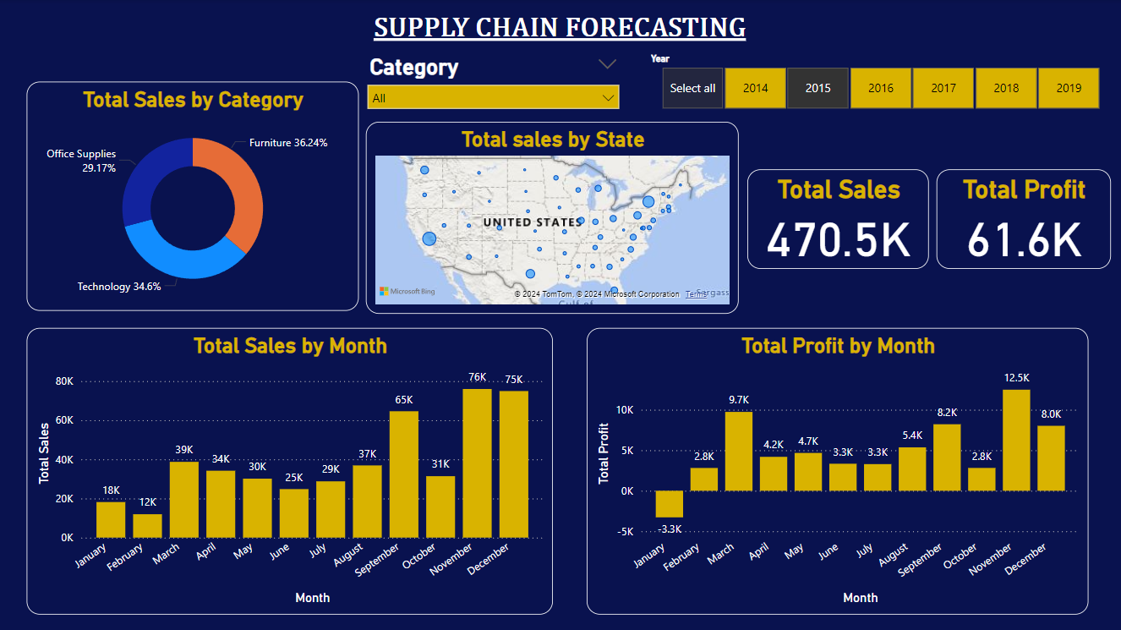

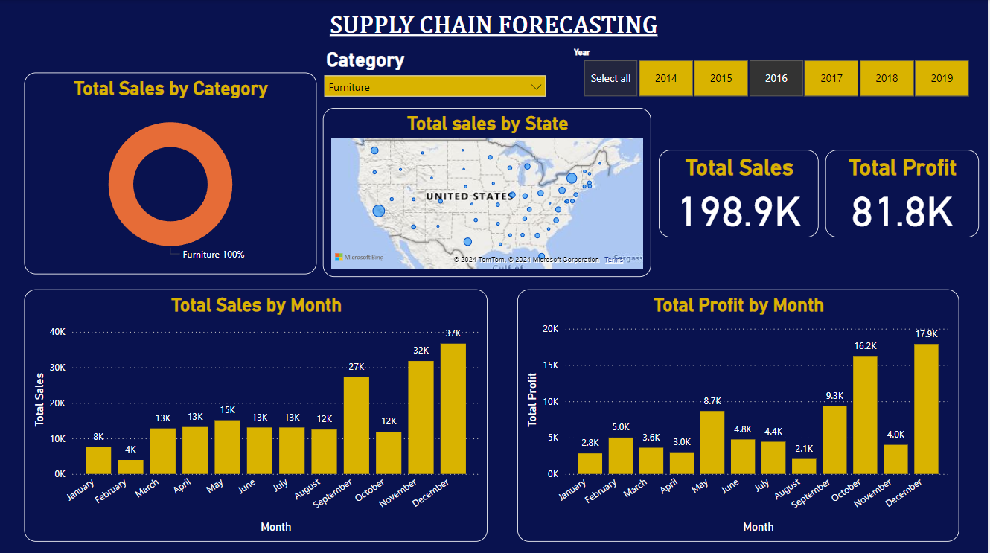

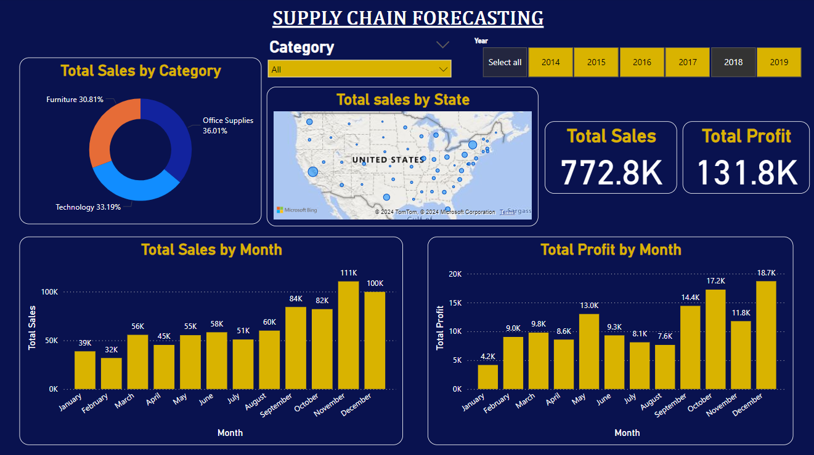

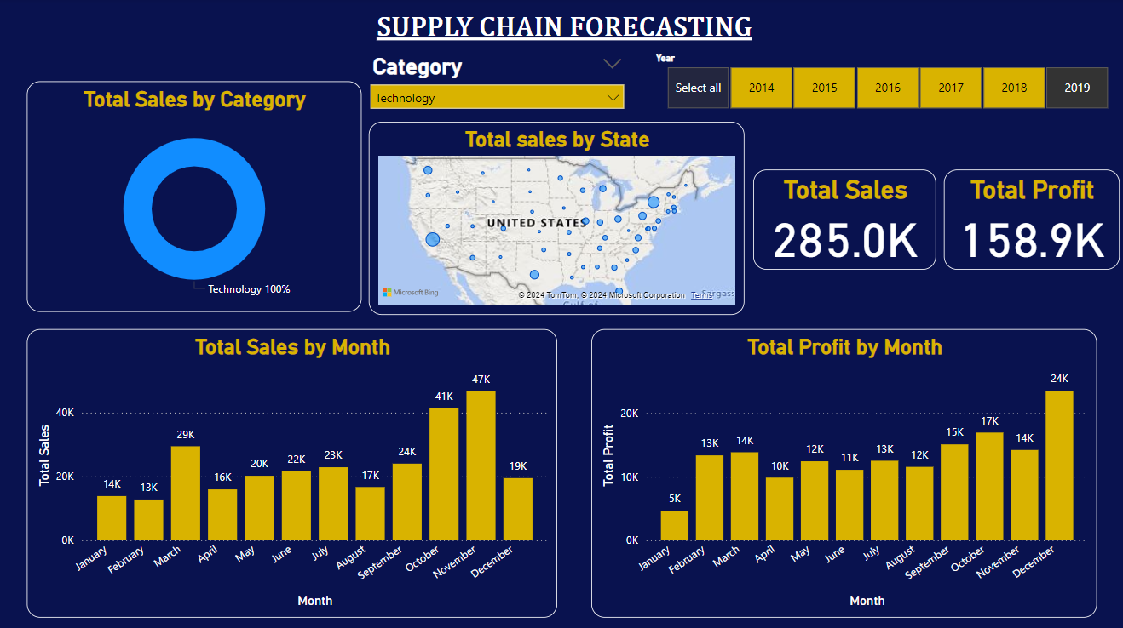

Conclusion

The SARIMA model provides valuable forecasts for sales and profit, thereby guiding the superstore in taking strategic decisions for 2018 and 2019. The Power BI dashboard offers an interactive and comprehensive view of the historical and forecasted data, facilitating better decision-making and planning.